### Controls

[0] Remove all effects

[1] Add Gradient effect

[2] Add Blur effect (<> keys control blur size)

[3] Add Underwater effect

[4] Add Depth of Field effect (OP keys control bokeh size, TY keys control focal plane and UI keys control the distance between near and far planes)

[5] Add Retro effect (NM keys control pixel size)

[6] Add Bloom effect (<> keys control bloom size, XC keys control the number of lens star flares, VB keys to control bloom threshold)

[7] Add Dilation effect (OP keys control spread, Q key to change shape)

[8] Add Chromatic Aberration effect

[9] Add Outline effect (KL keys control outline threshold)

[F1] Add Hue Shift effect

[F2] Add Frosted Glass effect

[F3] Decrease motion blur

[F4] Increase motion blur

[F5, F6] Focus depth of field's focal plane on object (cube, crate, lower wall, upper wall, teapot, troll, no focus), moving focal plane removes focus

[F7] Show selection effect on focused object

### Use of Post-Processing in a Graphics Application

Post-processing is applied after a scene is rendered and can be used to enhance and change how a scene looks via a variety of effects. This is achieved by rendering the scene to a texture and then applying any post-processes to this texture before rendering the result to the screen.

These effects can be simple, for example adding a colour tint or darkening the edges of the screen. Post-processing can also be used to achieve more complex effects, such as bloom (light bleeding out of bright areas) or ambient occlusion (changing how much ambient lighting different parts of the scene are receiving depending on how recessed each area is). Simple post processes usually only need access to the original image, while the more complex ones might need additional textures, such as a depth or normal map. Some post processes need more than one pass and multiple passes are often more efficient.

### Implementation

#### Gradient

The gradient effect was initially implemented as a tint. Two colours (float3) values were added to the post-processing constants and the shader interpolated between them using the v position, then replaced a portion of the original colour with this interpolated tint colour.

The implementation was changed later - instead of two colours, two floats between 0 and 1 are given. These floats represent hue. The original colour of the pixel is converted to the HSL colour space, and the hue value is replaced with an interpolated number. This creates a better tint effect that does not affect the sharpness of the scene. It also creates a more complex gradient if there are distinctly different hues between the two hues given.

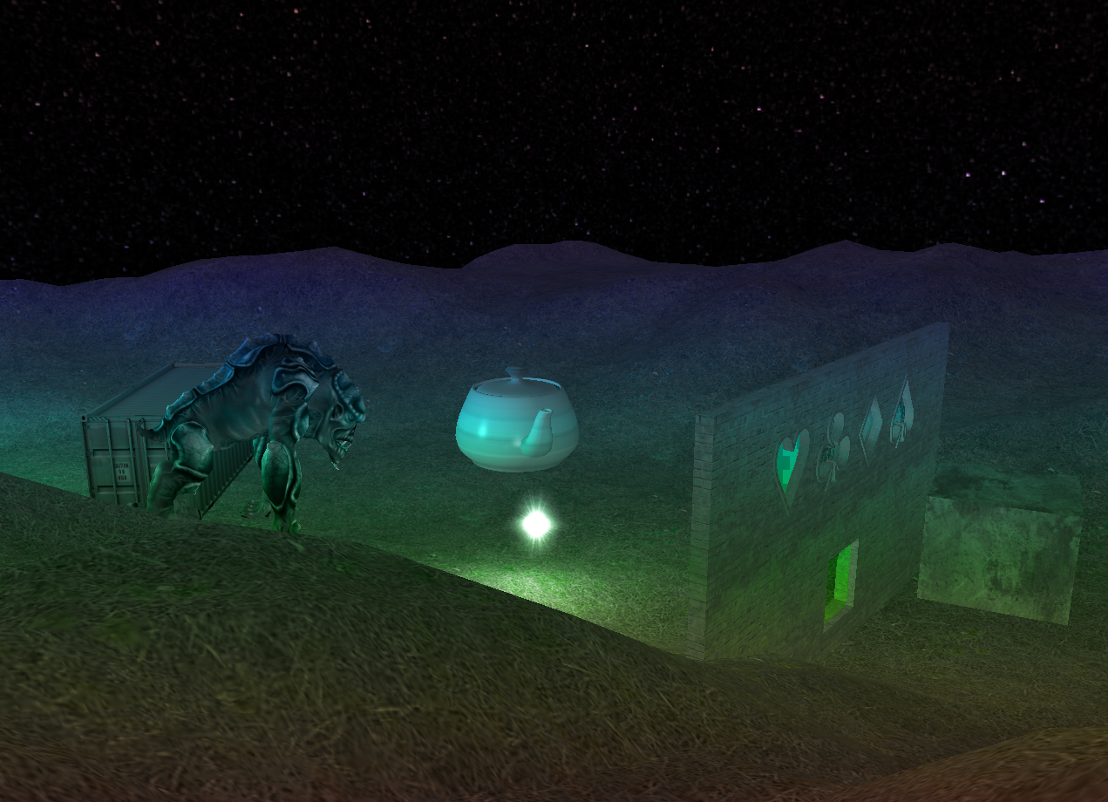

#### Blur

A two pass Gaussian blur was implemented. Two pixel shaders - BlurX and BlurY are created. Each shader samples the texture a given number of times on its given axis in turn. The sampled colours are weighted using a Gaussian function, then the final colour is divided by the total weight. The double pass is achieved by swapping the textures and resource views after each shader is applied, so that BlurX works with the original scene render and BlurY works with the result of BlurX. This is much more efficient than a single pass blur, as 150 samples on each axis only add up to 300 instead of 22,500.

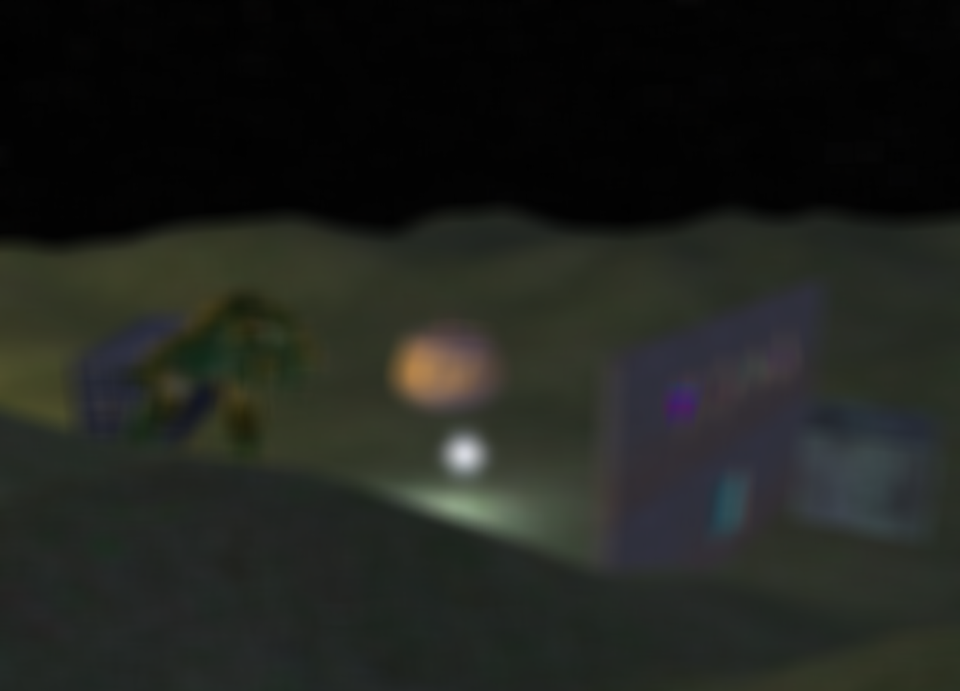

#### Underwater

The underwater effect does two things - it changes the hue and brightness of each pixel based on the values passed to it (the values change depending on the y position of the camera) and it distorts the image by sampling a position at an offset based on a passed timer value and the position of the pixel.

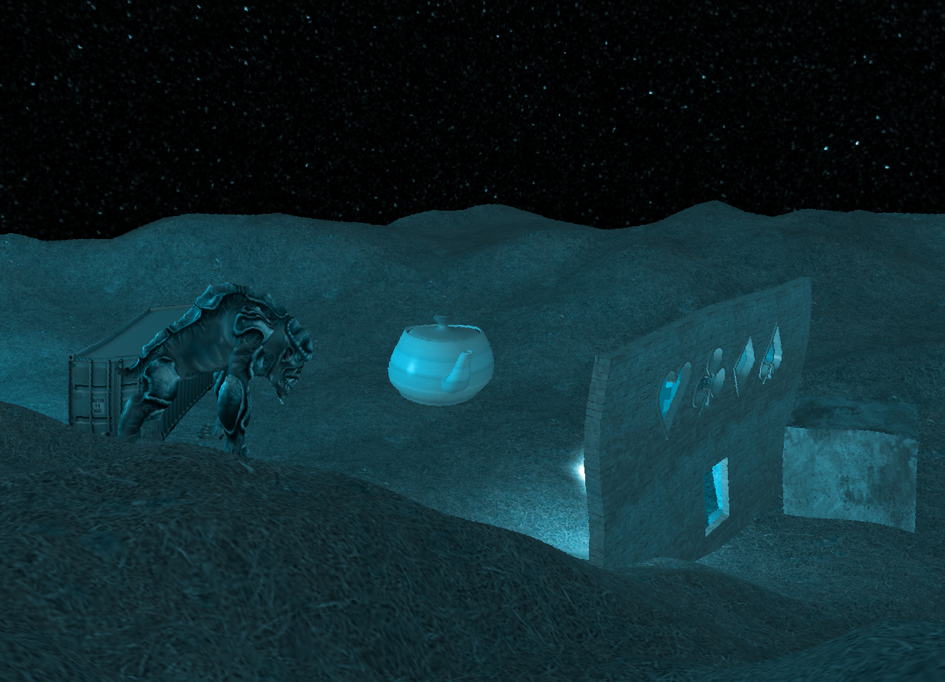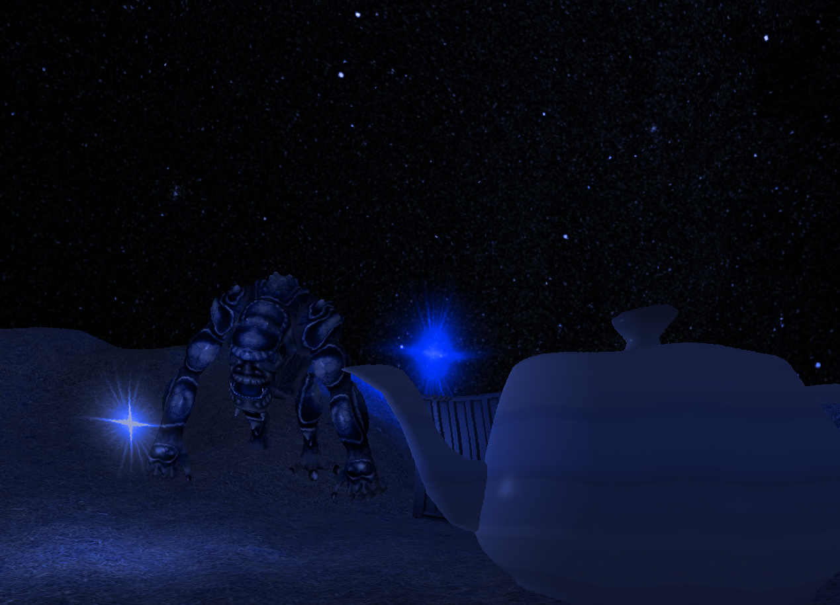

#### Multiple Effects at the same Time

An additional texture and resource view were added to make it possible to switch between two textures when applying post-processes. The first post-process uses the first resource view and draws to the second texture, the second post-process uses the second resource view and draws to the first texture, and so on. This way one effect can be applied on top of another. When pressing a key that corresponds to a post-process, the post-process is added to a list. The list is iterated through every frame, applying the post-processes in the order they were added.

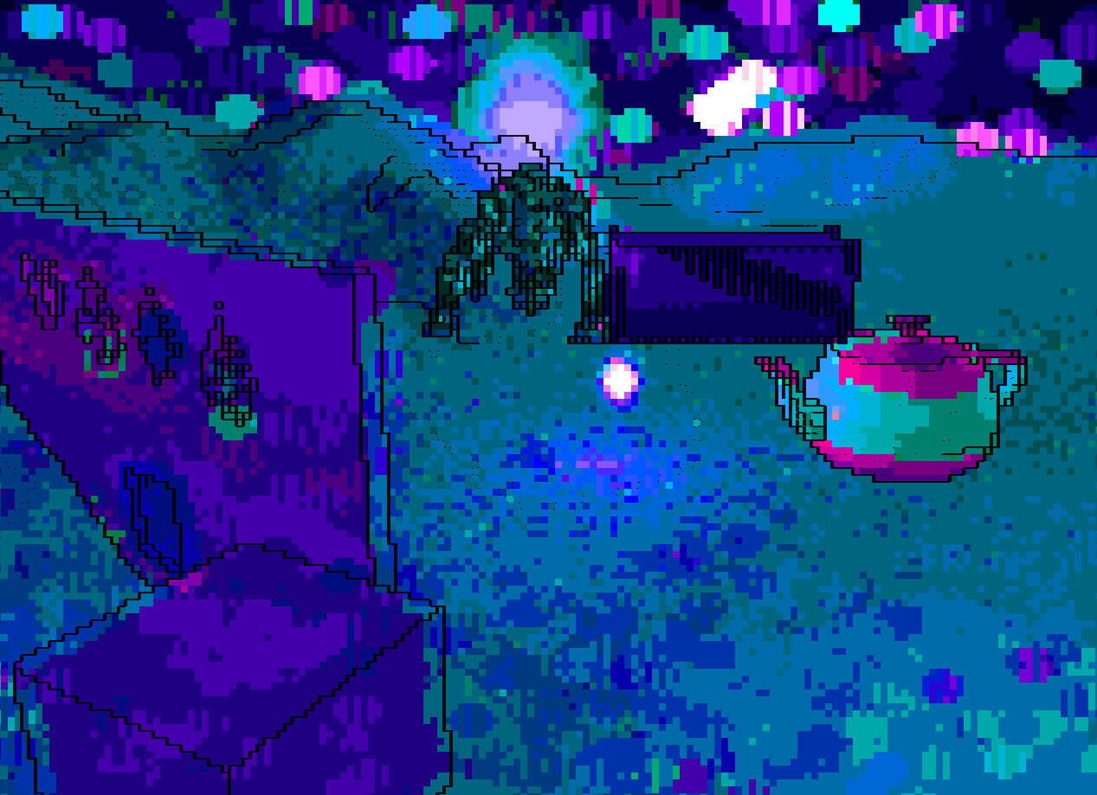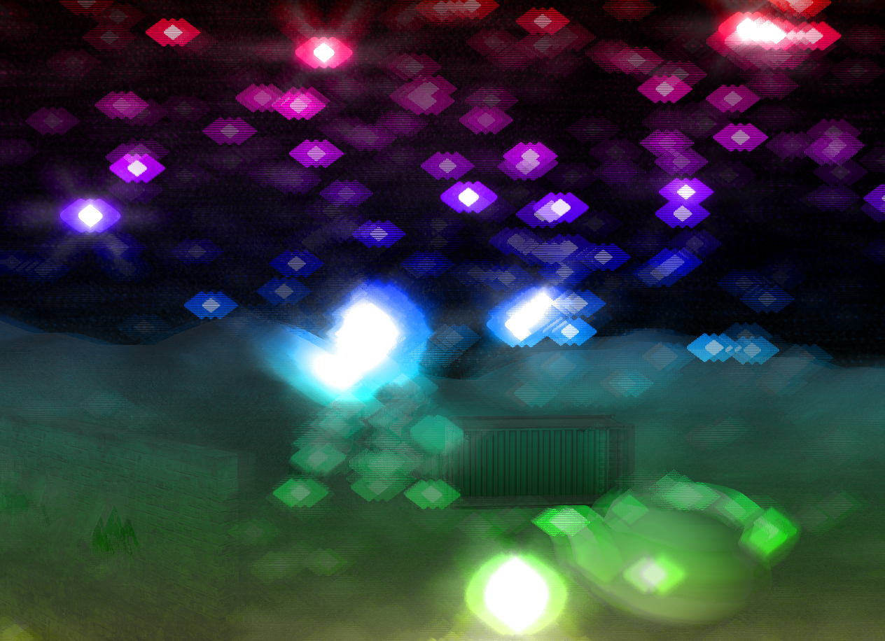

#### Feedback

The final image with all the post-processes applied is copied to the back buffer so that it can be shown on screen. The copy post process has been updated to set the alpha value to one defined in post-processing constants. If this value is lower than 1, the copy to back buffer is made to use the alpha blending state instead of no blending, which creates an adjustable motion blur effect.

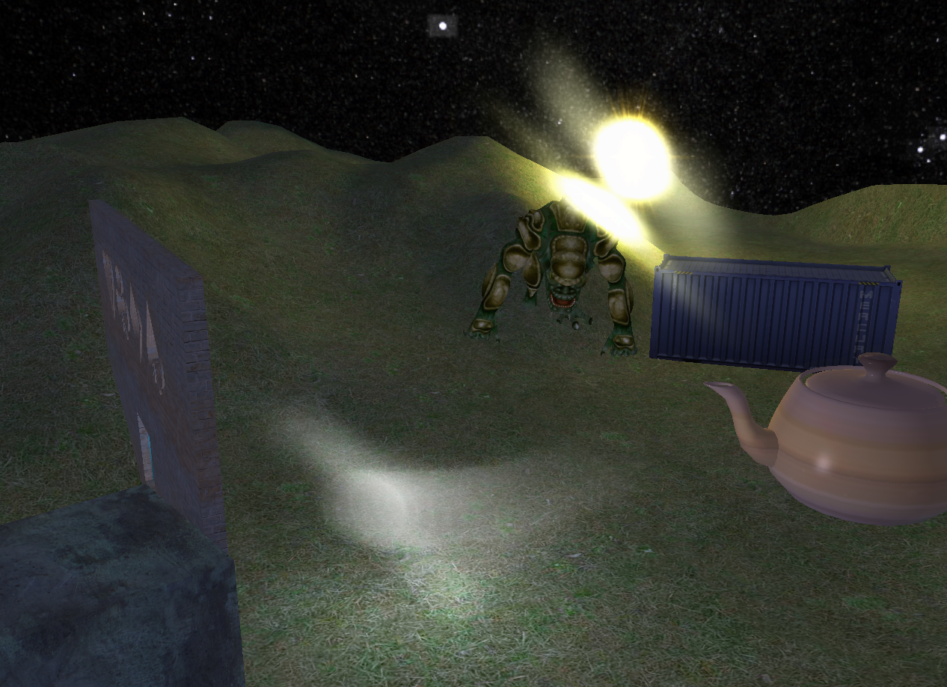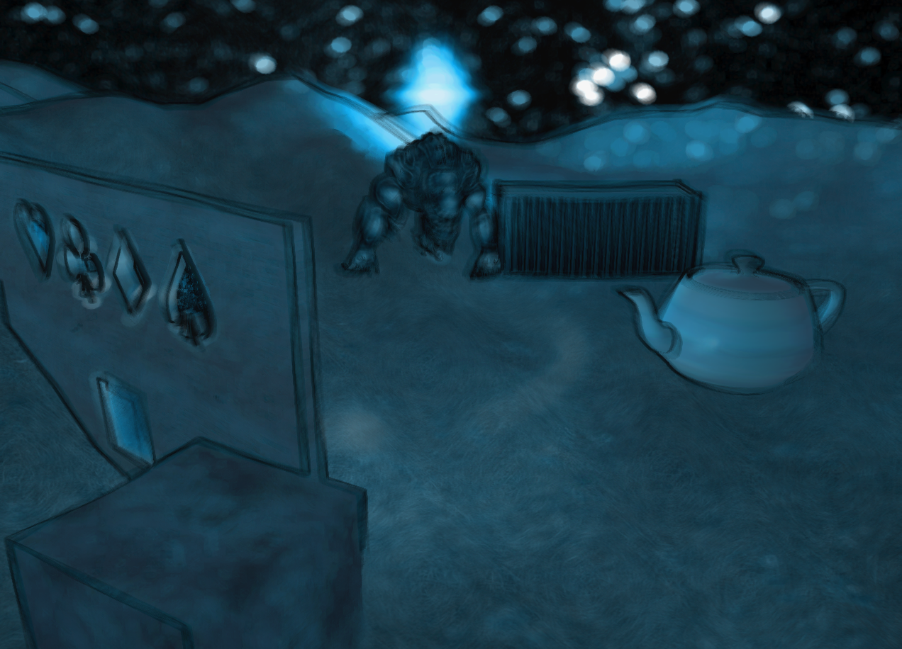

#### Polygon Post-Processing

The walls have been added to the scene and a list of polygon post-processes has been created, holding the matrices and points of each polygon, as well as the post process type to be applied to it. The list of polygon post-processes is iterated through first, followed by the list of full screen post-processes, making it possible to have both types of post-processes at the same time. When a post-process is applied to a polygon, the points are first looped through and translated to their viewport positions. The polygon points and post-process settings are then passed to the shaders and a special polygon vertex shader is used to draw the polygon. The vertex shader gives the polygon UVs that determine which part of the scene texture is affected.

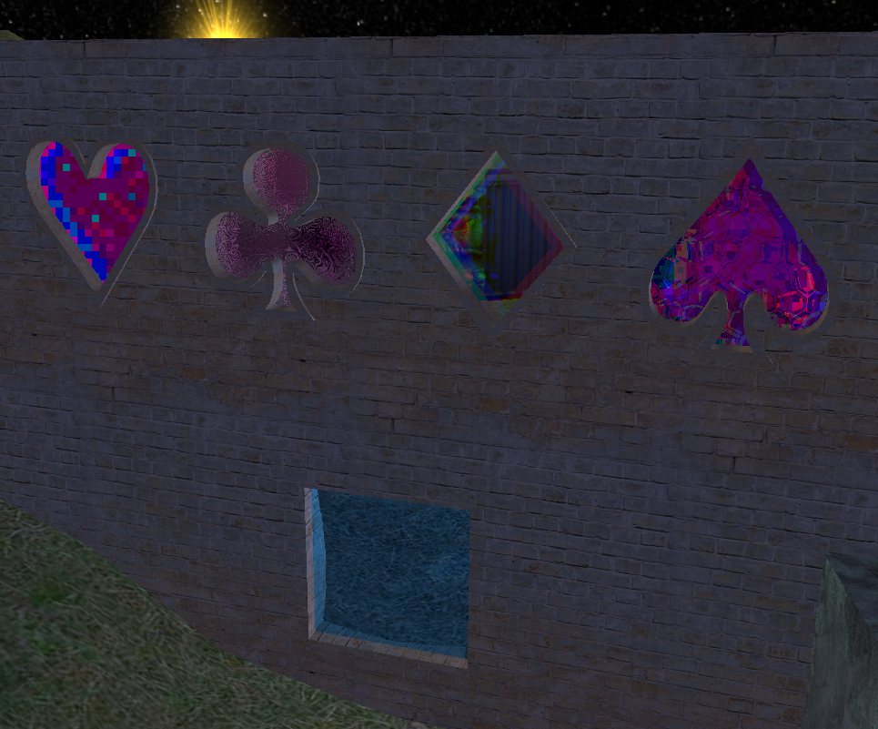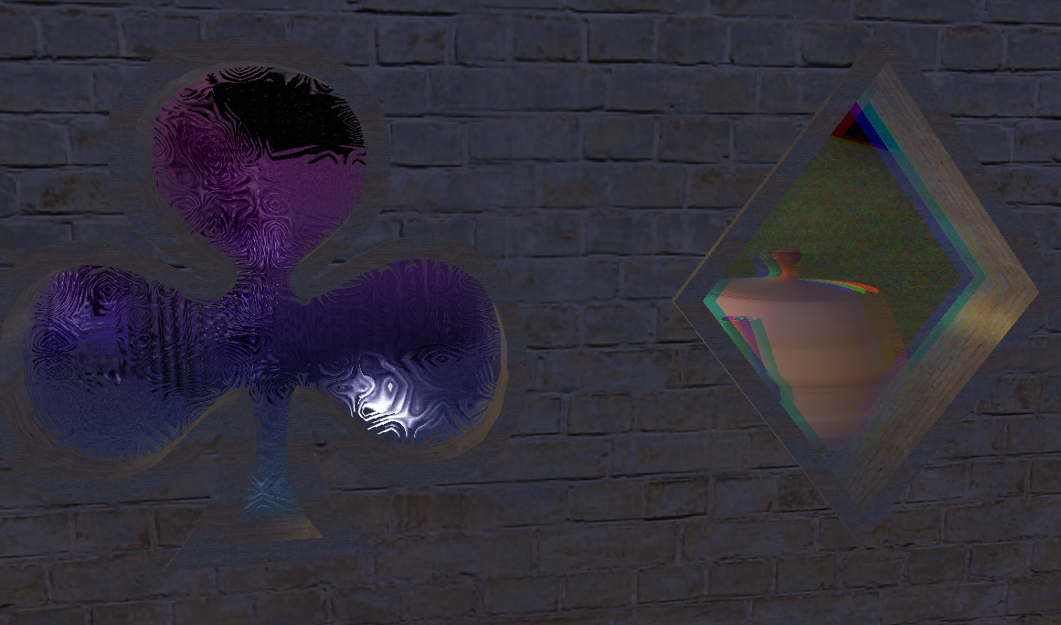

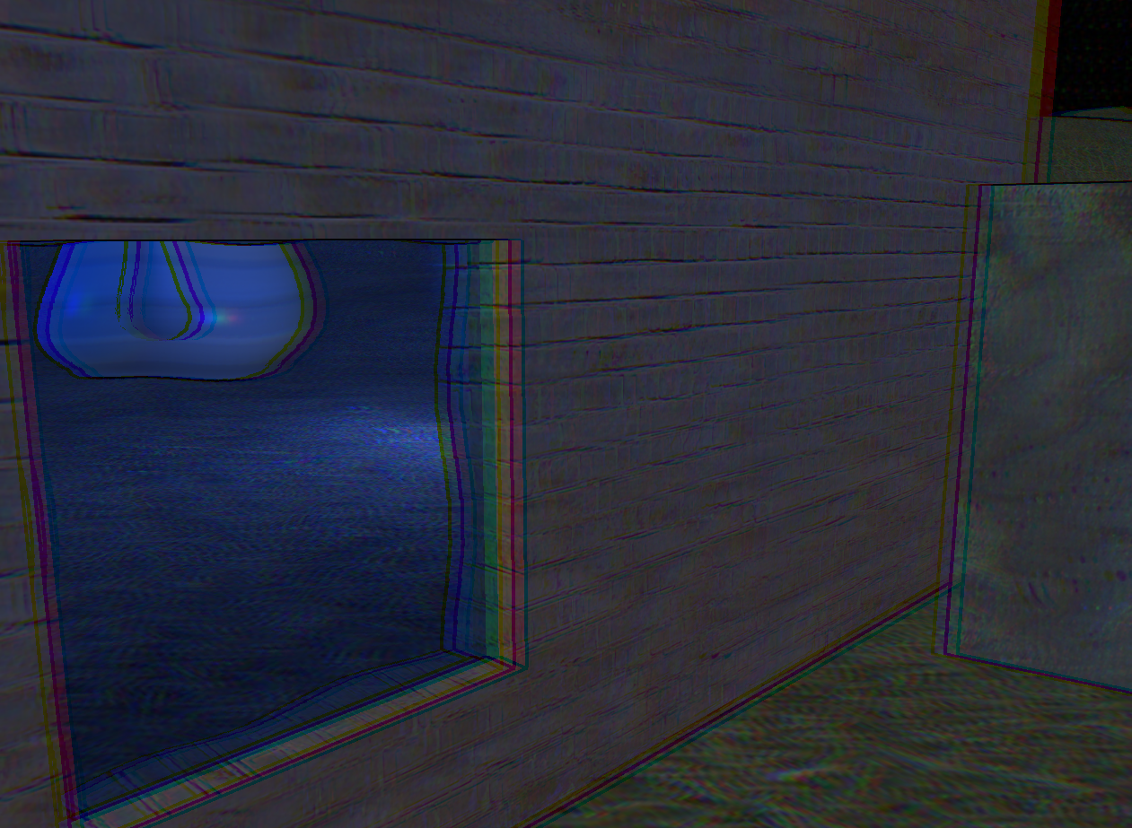

#### Retro Game Mode

This post-process takes the scene UV for a given pixel and multiplies it by the number of pixels. This value is floored and divided by the number of pixels, which means that multiple pixels get their sampled colour from the same exact spot, giving the scene a pixel look. The colour of the pixel is further modified - the colour is converted to HSL and a similar method is used to limit the range of possible hues, brightnesses and saturations. The hue is also limited to a given range, and shifted based on the brightness of a pixel. The colour is then converted back to RGB. The size of pixels and range of colours can be set in the constants.

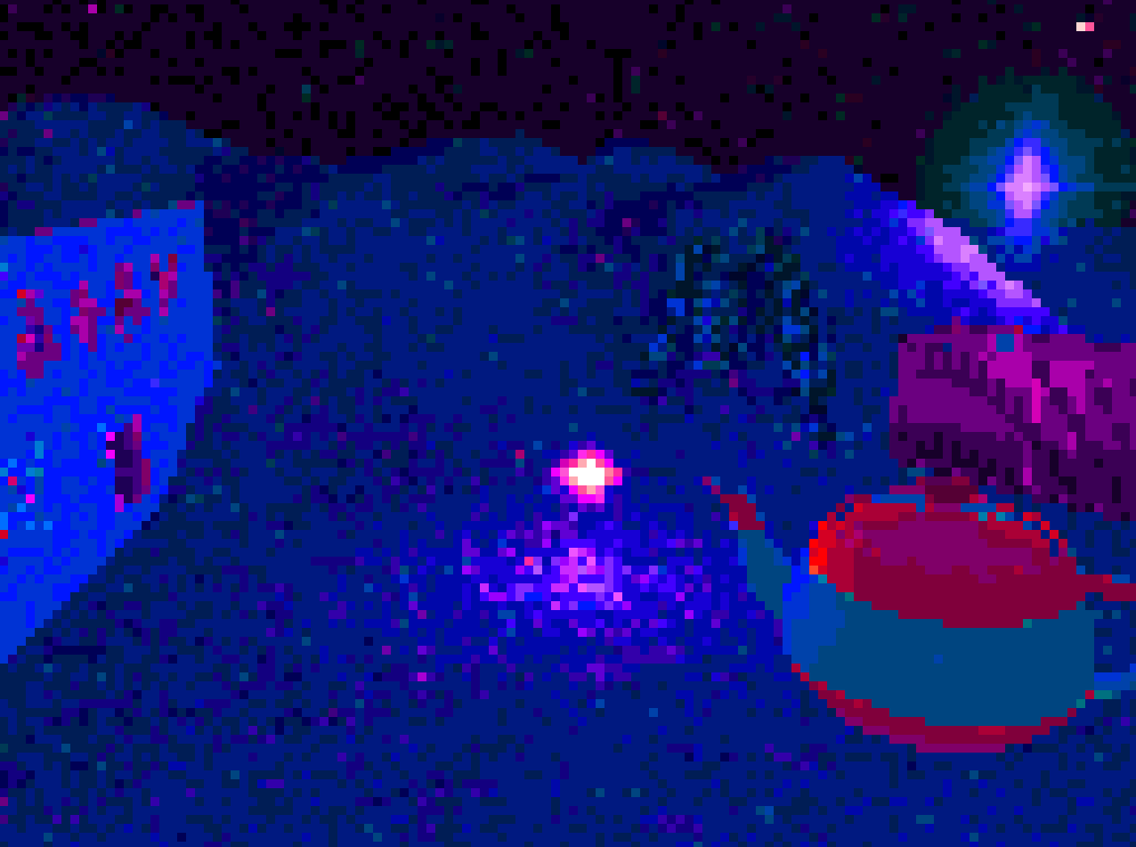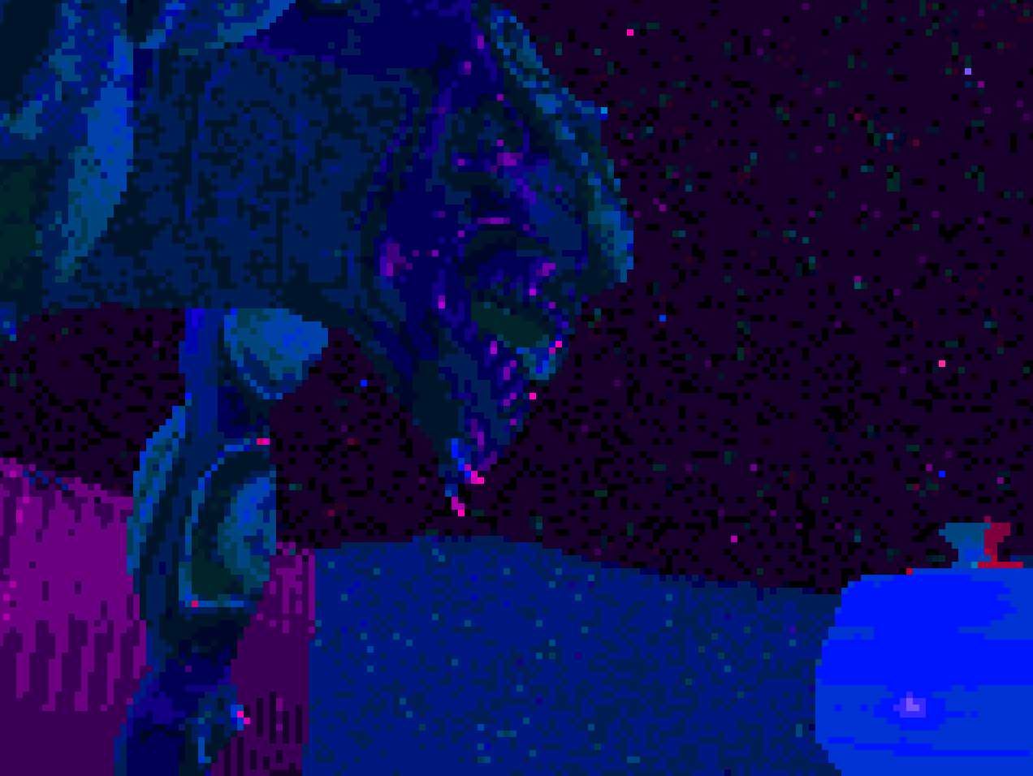

Chromatic Aberration

This effect samples the scene separately for each RGB colour channel. Each channel can be offset by a given amount, which results in a chromatic aberration effect.

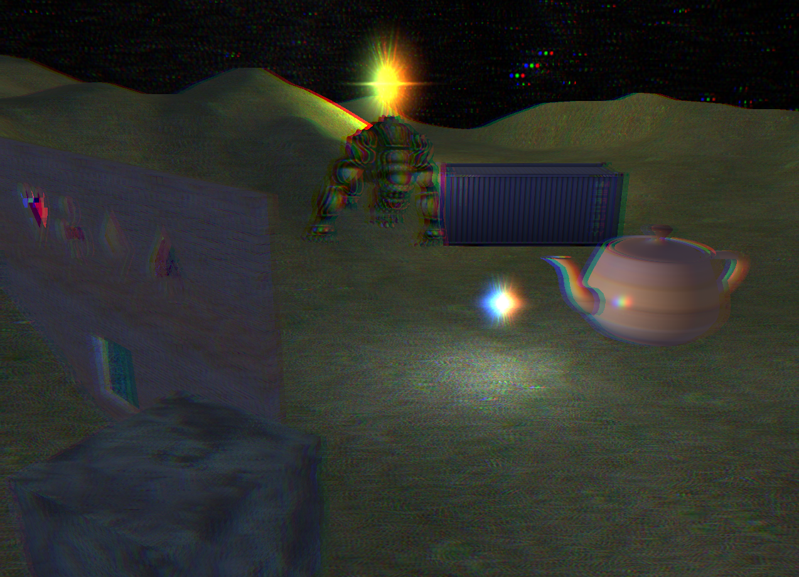

#### Frosted Glass

The scene texture is sampled at several offsets, the size of which is defined in the post-processing constants. A sample is also taken from a noise texture using the area uv and a given frequency. The samples are then interpolated together using a spline function, which results in a distorted image.

#### 

#### Bloom

The bloom effect needs multiple shader passes. Two temporary textures are used for this. First, a texture is created from the scene texture. If the brightness of a pixel is above a given brightness threshold, it is saved to the texture. Otherwise, the pixel is left black. Then this texture has a Gaussian blur applied to it. Optionally, directional blurs can also be applied. The number of these blurs can be changed and they all use the same texture. Their effects are additively applied to another texture to prevent them blurring the effects of one another. The directional blur is similar to a Gaussian blur, but the offset in which it samples pixels is two-dimensional and comes from the post-processing constants. It is used to create flares at given angles. The length, angle and number of flares can be changed. After that, the resulting texture is added to the scene texture.

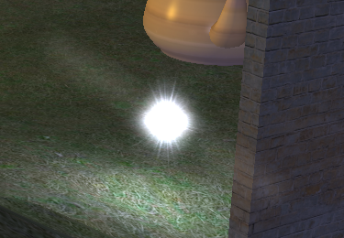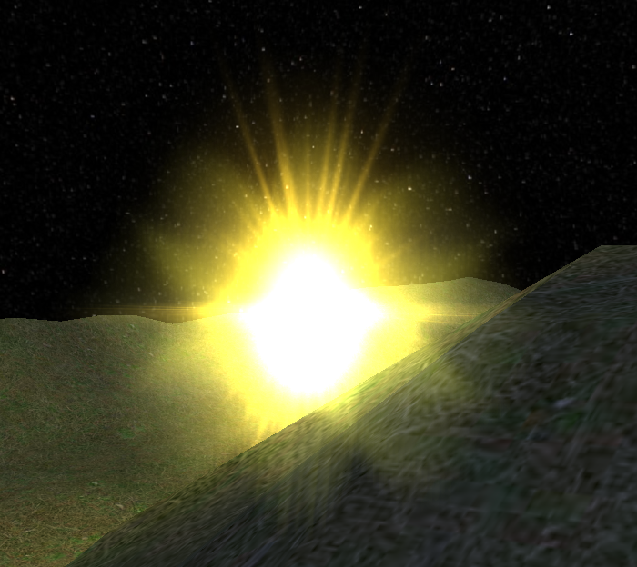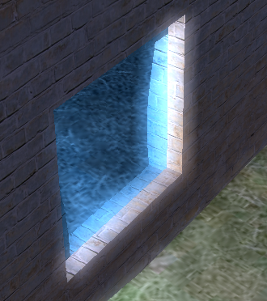

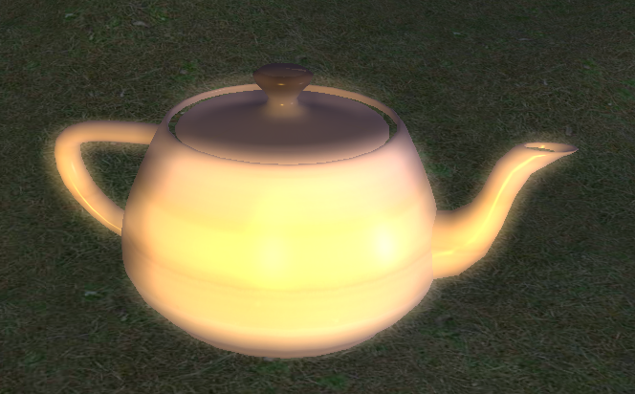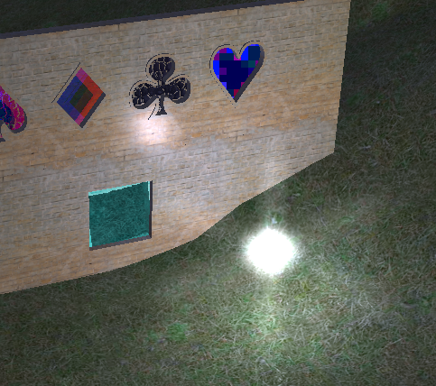

#### Dilation

This post-process samples the scene in a given range and keeps track of the brightest colour. It then interpolates between this colour and the original colour of the pixel based on the brightness and a given dilation threshold. The shape in which the colours are sampled can also be set in the constants - the scene can be sampled in a square, circle or diamond shape. If circle or diamond is selected, some of the sample offsets are ignored.

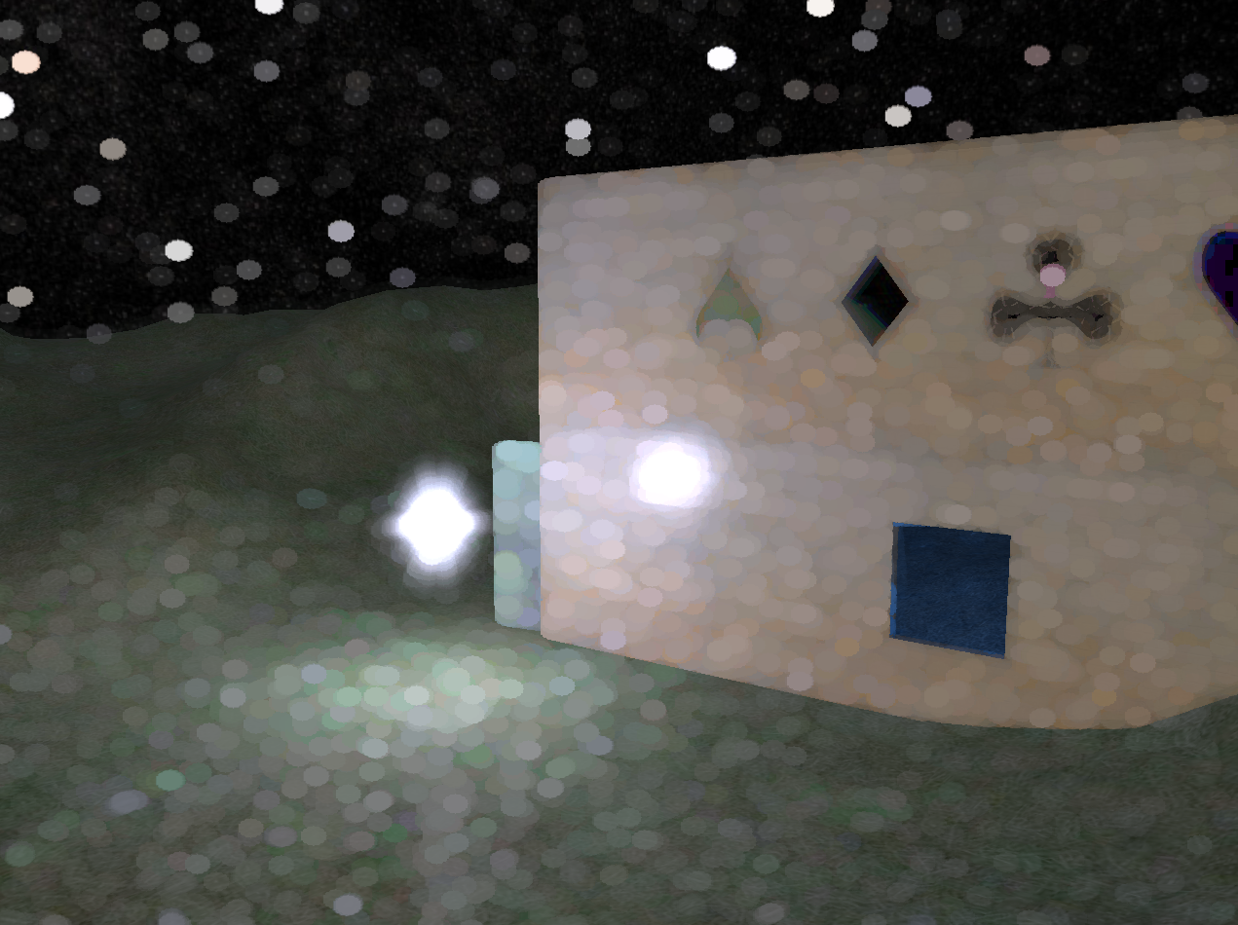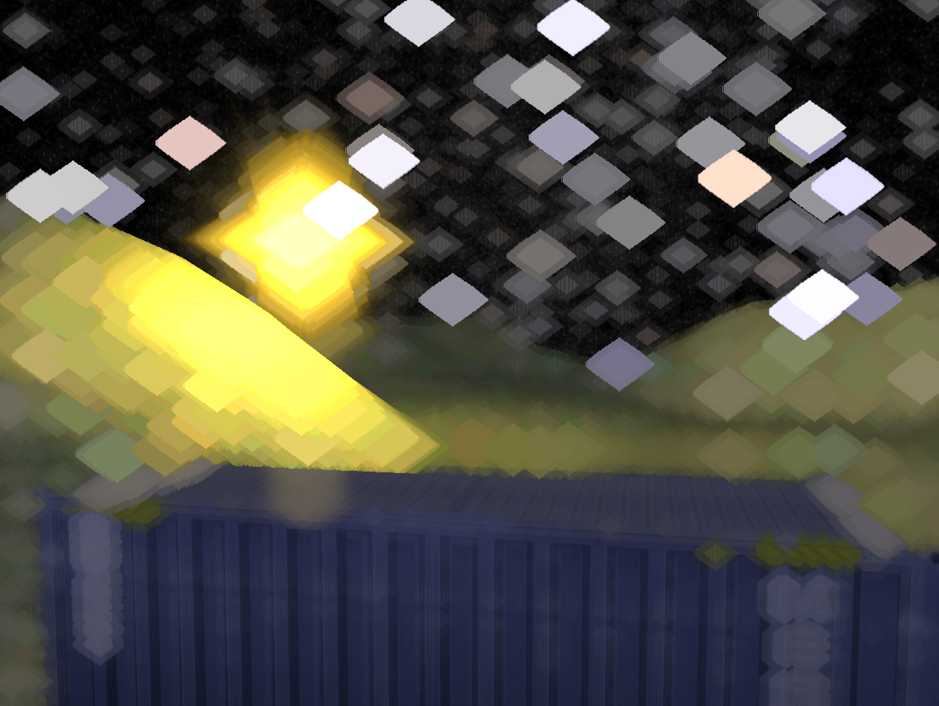

#### Outline

A new pixel and vertex shader were created to save the normal vectors and depth of each pixel to a texture. This texture is affected by some of the post-processes that have a distortion effect on the image along with the scene texture. The outline post-process makes use of this texture to determine whether the pixel is part of an edge. It compares the pixel with nearby samples and if the difference is bigger than a given threshold, it makes the pixel darker. The thickness of the lines can be set in the post-process constants and it affects the sampling offset.

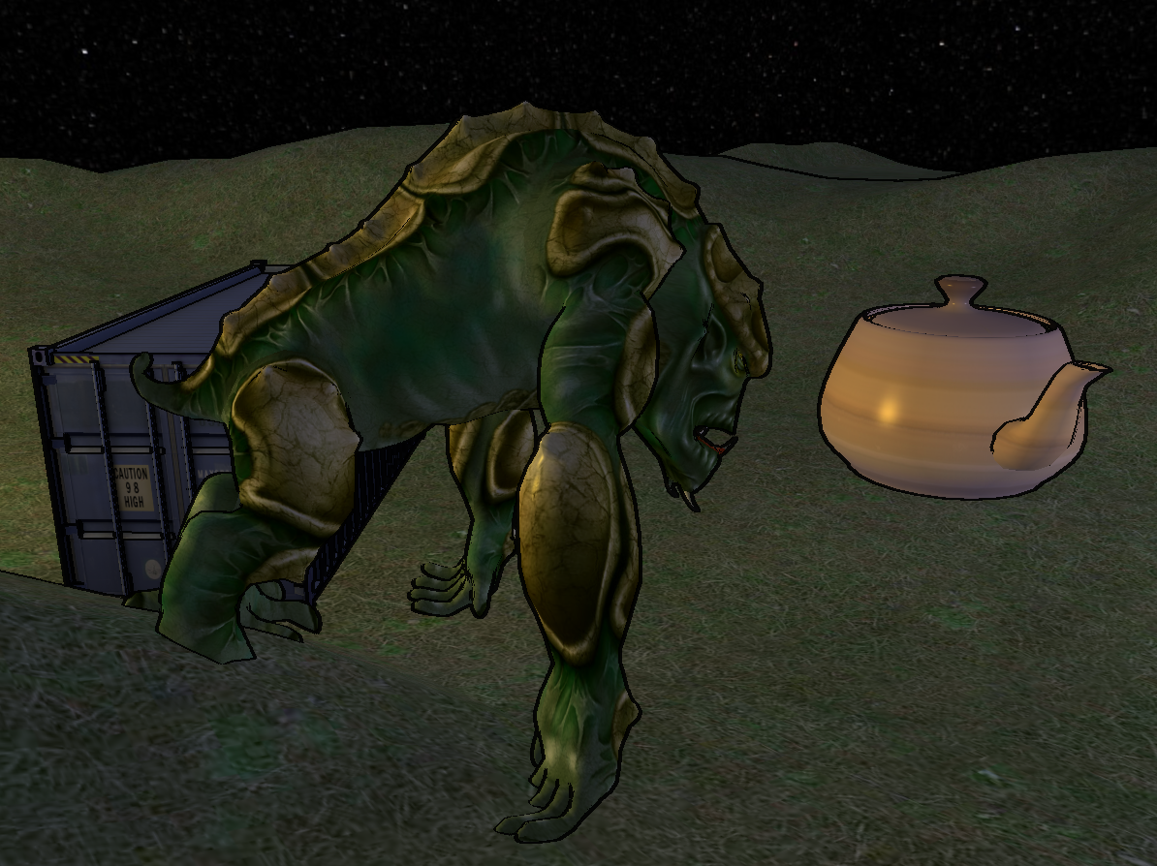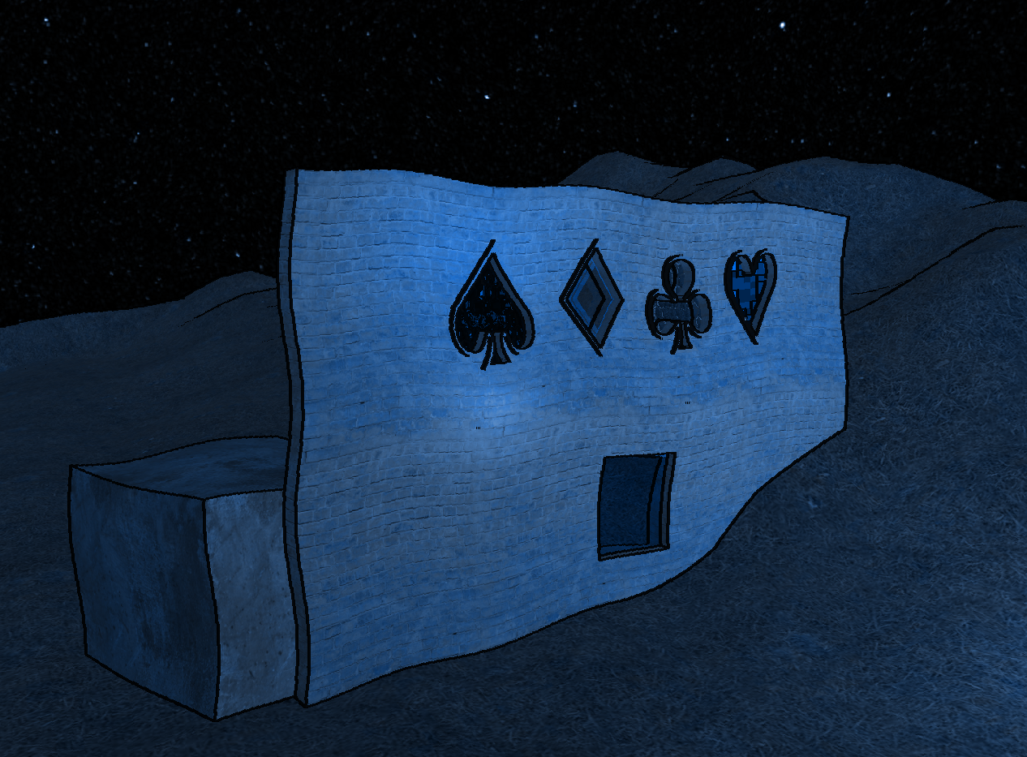

#### Depth of Field

The depth of field post-process is a similar effect to dilation, but the effect of dilation varies depending on the pixel's depth. Depth is obtained from the depth texture passed to the shader, and based on it and the focal, near and far planes in the post-processing constants a dilation value between 0 and 1 is obtained. When sampling around the pixel the search still looks for the brightest pixel, but new criteria are added to ensure the dilation doesn't leak to or from sharp objects. The sampled position needs to have a high enough dilation value and its depth cannot be too big compared to the depth of the pixel. This ensures that only objects in front can "leak" to objects in the back and not the other way around.

The objects are stored in a list, and it's possible to focus the focal plane on one of the objects. This is done be translating the object's position to viewport position and deriving the depth from it, then setting the focal plane to that value.

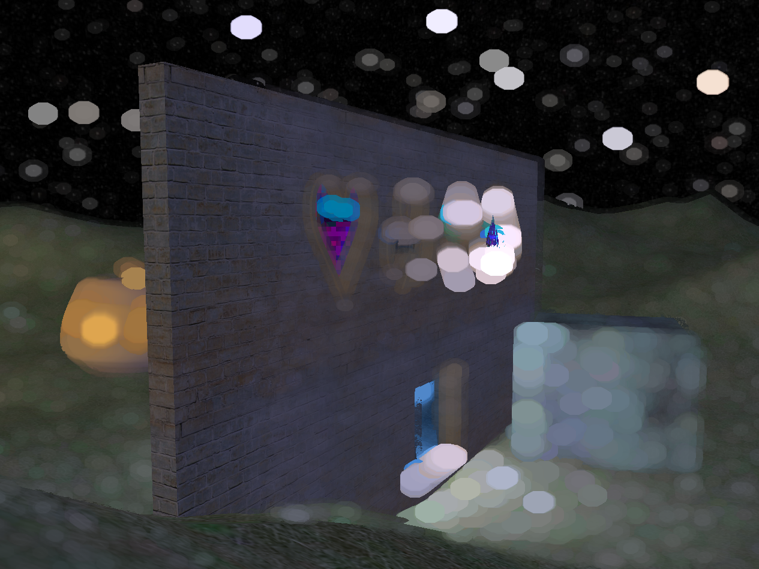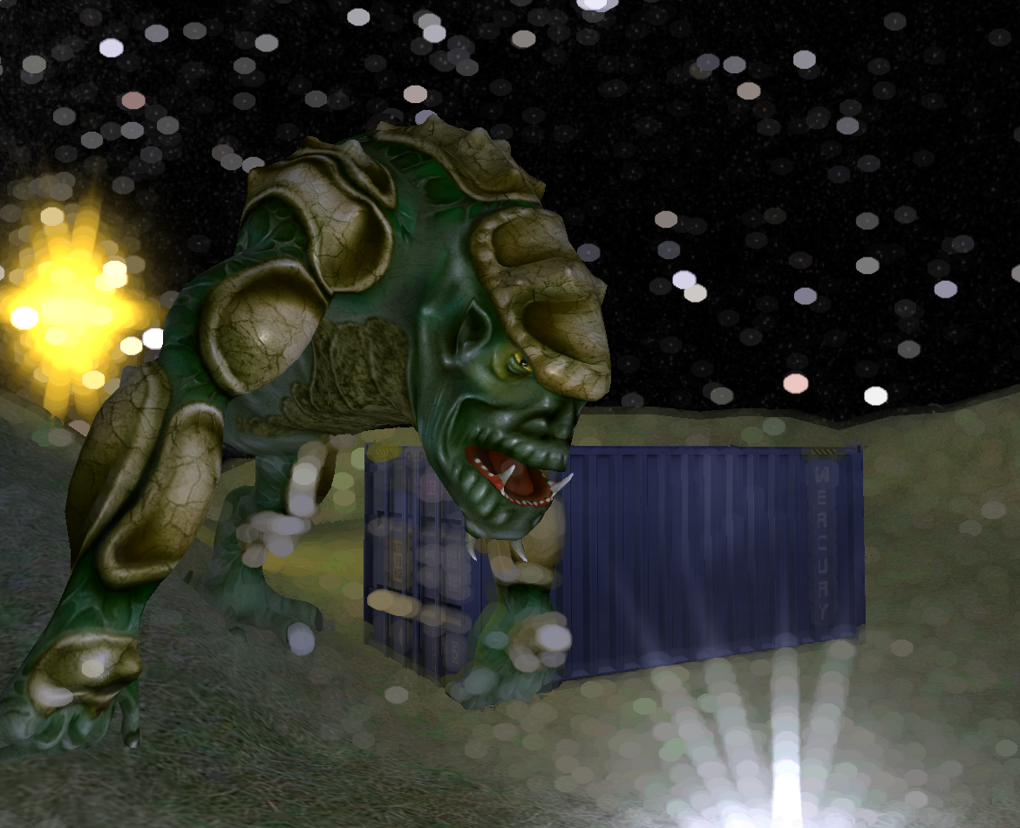

#### Selection

This post-process shader uses the depth texture and a texture that only has the depth of the currently focused object rendered to it. If a pixel has been rendered to the focused texture, it is not affected. If the focused texture is not near the pixel, it is also ignored. If it is, and the focused depth is not higher than the pixel being drawn, a white colour is returned. A cull none state is used when rendering the focused object to prevent lines from appearing inside it. This method could also be used to create a backdrop glow or similar if a larger area was sampled and the results were weighted based on the distance from the focused object.

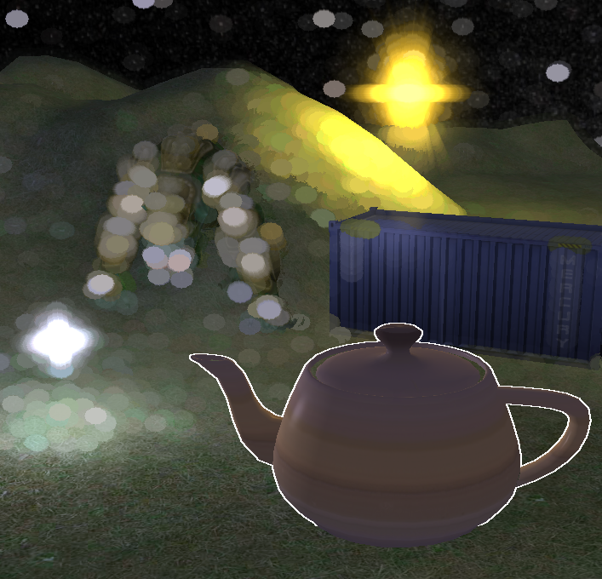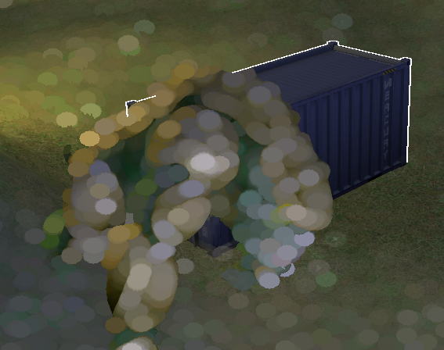

### Potential Improvements and Extensions

Currently, the settings (such as various colours and change levels) for each post process are shared across all instances of this post process. If the same effect is applied twice, both instances of it will use the same settings, which may be limiting. It also does not make for readable code, which is currently a wall of settings being applied and updated every frame. This could be improved by making each type of post process represented by its own class and having that class responsible for storing and updating the settings as needed. The class would have the following functions:

* Setup - this would be used to set up the initial values applicable to the given post process, as well as their change over time or change d00000000ue to controls being pressed and minimum and maximum values.
* Update - this would be used to update the values every frame. It would also optionally check for relevant input
* Apply - the current settings would be applied to gPostProcessingConstants passed into the function right before applying the post process.

This would make the code more readable and easier to expand upon. I would also allow for controlling just one post-process at a time if needed and even make it possible to change the textures used by each post-process without having to define it and make separate cases for it multiple times. The controls could be simplified if only one post-process is controlled at a time - currently each setting has its own controls, which can be confusing.

The post processes are currently applied in the order they were added to the list. This may be an issue when applying polygon post-processes, as when looking at one through another one would expect the effect in front to be applied second. This could be solved by sorting the list by the depth of each area and polygon before applying the post processes.

The gradient post process shows noticeable colour banding. This could be improved by adding some manner of distortion on top of the hue change.

The hue change post process uses the HSL colour space, which does not produce a perfect colour shift when perceived by the human eye. Using a different colour space, for example CIELAB, could potentially produce better results.

The dilation and depth of field post-processes are extremely inefficient due to each being done in a single pass. The performance could be improved by reducing the number of samples and applying a Gaussian blur.

The depth of field post-process does not produce perfect results. Further work and research would be needed to make it more accurate.